**Assignment-4**

**1) Write a menu driven shell script, which will print the following menu and execute the given task.**

* **Display a calendar of current month**
* **Display today’s date and time**
* **Display username those are currently logged in the system**
* **Display your name at the given x,y position**
* **Display your terminal number.**

**Code)**

echo Menu

echo "1. Display a calendar of current month"

echo "2. Display todays date and time"

echo "3. Display username those are currently logged in the system"

echo "4. Display your name at the given x,y position"

echo "5. Display your terminal number"

echo "6. Exit"

read n

case $n in

1) cal;;

2) date;;

3) whoami;;

4) clear

echo "Enter x,y position"

read x

read y

tput cup $x $y

whoami;;

5) tty;;

6) exit

esac

**Output)**

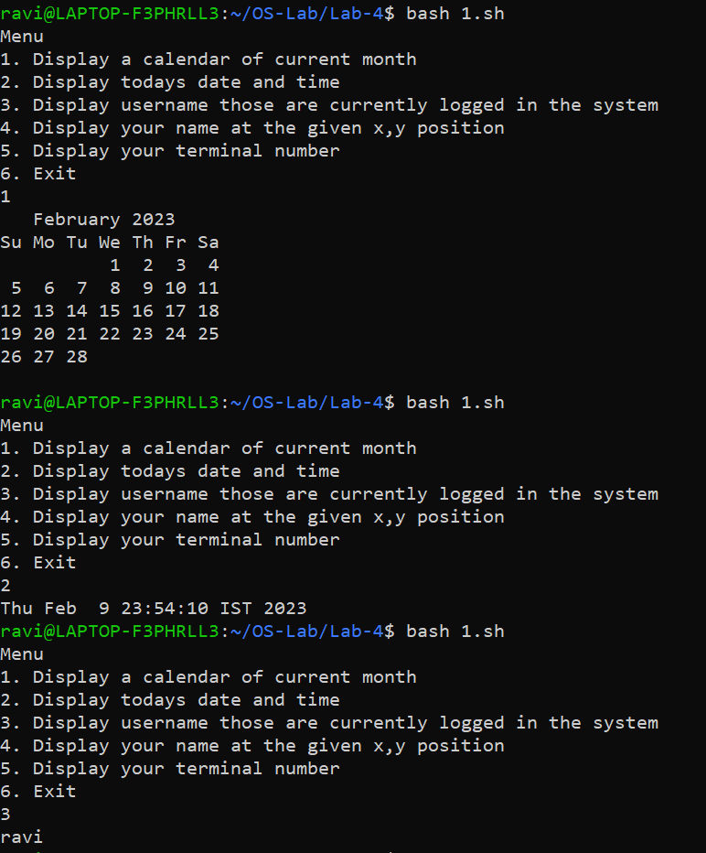

**2) Write a shell script which will generate first n Fibonacci numbers such as: 1, 1, 2, 3, 5, 13, … etc.**

**Code)**

echo "Enter term:"

read n

echo "Fibonacci series:"

a=0

b=1

echo -n $a " "

echo -n $b " "

for ((i=3 ;i<=$n;i++))

do

c=$(($a + $b))

a=$b

b=$c

echo -n $c " "

done

echo " "

**Output)**

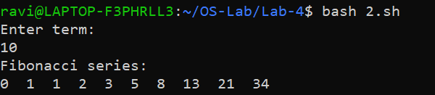

**3) Shell Script to print half pyramids using number.**

**Code)**

for ((i=1; i<=5; i++))

do

for ((j=1; j<=i; j++))

do

echo -n "$j "

done

echo

done

**Output)**

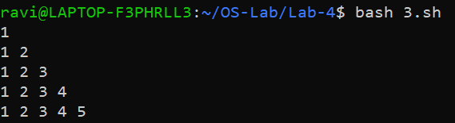

**4) Write a shell script to find the reverse of a given number.**

**Code)**

echo -n "Enter a number: "

read n

echo "Entered number is $n"

reverse=0

while [ $n -gt 0 ]

do

r=$((n%10))

reverse=$((reverse*10 + $r))

n=$((n/10))

done

echo "Reversed number is $reverse"

**Output)**

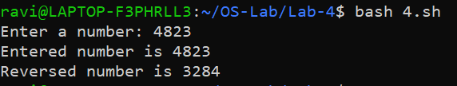

**5) Write a shell script to find the sum of two floating point numbers.**

**Code)**

echo -n "Enter num1: "

read a

echo -n "Enter num2: "

read b

echo "scale=2; $a+$b" | bc

**Output)**

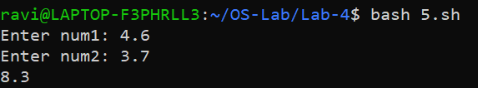

**6) Write a shell script to make the following operations menu based:**

* **Addition**
* **Subtraction**
* **Multiplication**
* **Division**

**Code)**

echo -n "Enter num1: "

read num1

echo -n "Enter num2: "

read num2

echo "Menu"

echo "1. Addition"

echo "2. Subtraction"

echo "3. Multiplication"

echo "4. Division"

read n

case $n in

1) res=$(($num1 + $num2 | bc));;

2) res=$(($num1 - $num2 | bc));;

3) res=$(($num1 * $num2 | bc));;

4) res=$(($num1 / $num2 | bc));;

esac

echo "Result: $res"

**Output)**

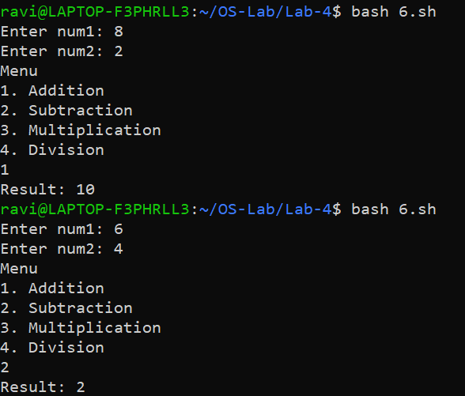

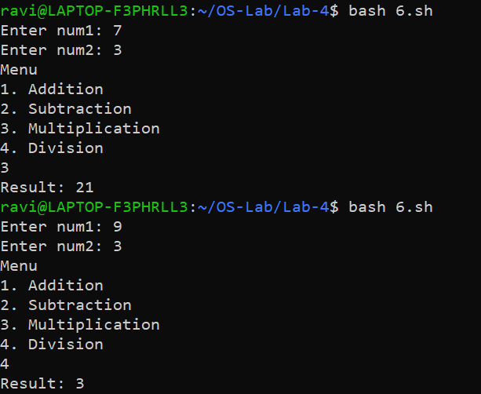

**7) Write a shell script to find the sum of all digits for a given number.**

**Code)**

echo -n "Enter number: "

read n

temp=$n

sum=0

while [ $temp -gt 0 ]

do

r=$(($temp%10))

sum=$(($sum+$r))

temp=$(($temp/10))

done

echo $sum

**Output)**

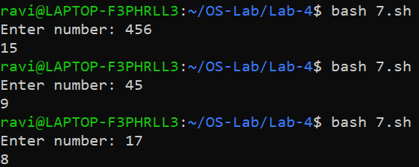

**8) Write a shell script to find the factorial of a given number.**

**Code)**

echo -n "Enter n: "

read n

fact=1

for((i=n;i>0;i--))

do

fact=$(($i*$fact))

done

echo "Factorial: $fact"

**Output)**

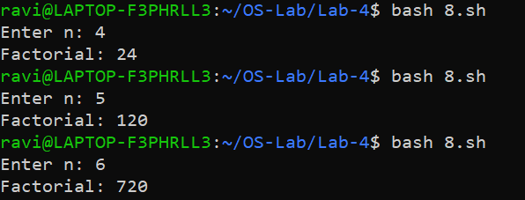

**9) Write a shell script which prints: invalid no. of arguments” if more than 5 command line arguments otherwise print “valid no. of arguments”.**

**Code)**

if [ "$#" -gt 5 ]; then

echo "invalid no. of arguments"

else

echo "valid number of arguments"

fi

**Output)**

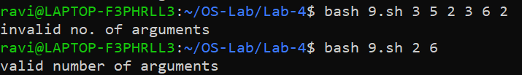

**10) Write a shell script that changes text to uppercase.**

**Code)**

echo -n "Enter text: "

read text

text=${text^^}

echo "Uppercase: $text"

**Output)**

